A Capstone Project Entitled

**ePahiram-(Micro Loans)**

*System Documentation*

Presented & Developed By:

Coligado, John Jason M.

Pandanan, Jhansept Kylo

April 2023

**Table of Contents**

**Title Page**

Table of Contents………………………………………………………………………………2

Introduction.....................................................................................................................3

Project Description…………………………………………………………………………….4

Project Scope.........................………………………………………………………………..4

Expected Acceptance Criteria...................................................................................10

Project Limitation (Out of Scope) ..................................................................................5

Entity Relationship Diagram...........................................................................................6

System Flowchart............................................................................................................7

Wireframes.......................................................................................................................8

System Architecture........................................................................................................9

Tools & Frameworks..............................................................................................9

Packages..............................................................................................................0

User Guide......................................................................................................................11

**Introduction**

ePahiram is a loan management system that offers a hassle-free and convenient way for individuals to loan gadgets and calculate monthly payments. In a world were keeping up with the latest technology trends can be difficult, ePahiram provides a solution by allowing users to apply for a loan to purchase the gadget they need. The system is equipped with a Loan Calculator feature that helps users make informed decisions before applying for a loan, while the Gadget Loan feature simplifies the loan application process, making it more convenient for users. ePahiram is designed to provide a seamless user experience, with responsive web design that enables access to the system on different devices. Overall, ePahiram is a timely solution that makes it easy and convenient for users to loan gadgets and manage their finances effectively.

**Project Description**

ePahiram is a loan management system that addresses the needs of individuals who are looking for a convenient and hassle-free way to loan gadgets and calculate monthly loan payments. In today's fast-paced world, people often need to keep up with the latest technology trends, but they may not always have the means to do so. ePahiram provides a solution by allowing users to apply for a loan to purchase the gadget they need, with a manageable monthly payment based on their preferred payment term.

ePahiram's Loan Calculator feature enables users to make informed decisions before applying for a loan, ensuring that they are comfortable with the monthly payment based on the loan amount and term they prefer. This feature makes it easy for users to plan their finances and manage their budget effectively.

The Gadget Loan feature of ePahiram simplifies the process of applying for a loan, with an approval process to ensure qualified applications. This feature eliminates the need for users to go through a lengthy loan application process, making it convenient for them to loan the gadget they need.

The ePahiram system is built with several project deliverables, including an ASP .NET Core 6.0 MVC Web App, a Web API, and an SQL Server database. To ensure a seamless user experience, the ePahiram system is designed using CSS and Bootstrap. These design frameworks enable responsive web design, making it easy for users to access the system on different devices, such as desktops, laptops, tablets, and smartphones.

Overall, ePahiram provides a solution that is relevant and timely in today's world, making it easy and convenient for users to loan gadgets and manage their finances effectively.

**Project Scope/Requirements**

**In Scope:**

The ePahiram project scope aims to provide a loan management system that caters to individuals who are looking for a convenient and hassle-free way to loan gadgets. The system features a Loan Calculator that allows users to make informed decisions before applying for a loan, ensuring that they are comfortable with the monthly payment based on their preferred loan amount and term. The Gadget Loan Application feature simplifies the process of applying for a loan, with an approval process to ensure qualified applications.

**Web Services (API)**

* + Authentication
    - JWT Token
  + Gadget Loan
    - CRUD

**Web Application (MVC)**

**User Side**

* Authentication and Authorization
  + Register
  + Log in and Logout
  + View Profile
  + Change Password
* Home
  + Loan Calculator
  + Gadget Loan
* Loan Calculator
  + Calculate Monthly Loan Payments
* Gadget Loan
  + Search
  + View All Gadgets
  + Apply for Gadget Loan
* My Purchase
  + View Gadget Loan Application
  + Withdraw Gadget Loan Application

**Admin Side**

* Authentication and Authorization
  + Log in and Logout
  + View Profile
  + Change Password
* Gadget Loan
  + Search
  + CRUD
* Manage Users
  + View All Registered Users
  + Delete User
* View Purchases
  + Search
  + View All Gadget Loan Applications
  + Approve and Decline Gadget Loan Application

**Functional Requirements**

The requirements in this document are divided into the following categories:

**System Requirement**

|  |  |  |
| --- | --- | --- |
| **Item** | **Rating** | **Description** |
| Login/Registration/ Logout | High | User will be able to login with their provisioned account details. Also, able to register new accounts. |
| Dashboard for user and admin | High | * Dashboard for user, to view the given loans and requirements * Dashboard for admin, to view purchases of the loan * Manage Application Status (Admin) |
| Purchases | High | List all Existing and archived purchases of the loan(admin) |
| My Purchase | High | List all the details for purchase (User) existing and archived |
| Gadget Loan | High | Provide list of terms, interest, and available gadgets for loan. Also, payment computation for the chosen entity. |
| Account Roles | High | -User must perform the indicated features for purchase, compute loan and views gadget loans. -Admin has the privilege to add Gadget Loan, update details, delete, view purchases history, and manage users |
| Loan Calculator | Low | Provide requirements and details for the loan (extra features) |

**Rest API**

|  |  |  |
| --- | --- | --- |
| **Item** | Rating | Description |
| Authentication | High | User will be able to login with his provisioned account details. |
| Gadget Loan Crud | High | API’s to access the database of the gadget loan and manage it using CRUD operation. |

**Expected Results**

* **Loan Calculator:** tool that helps users to estimate the amount of money they will have to pay each month to repay a loan based on the loan amount and the loan term they prefer. The user can input the loan amount and the preferred loan term (in months), and the calculator will compute the monthly payment and display the total amount payable. This helps the user to determine whether they can afford to make the loan payments and decide whether to proceed with the loan application.
* **Gadget Loan:** allows users to apply for a loan to purchase a gadget of their choice. However, users can only apply for one gadget at a time. The system admin has the authority to approve or decline user gadget loan applications. The admin has the capability to add a gadget for loaning by providing the gadget name, description, price, and image URL. The gadget will then be made available for users to apply for a gadget loan. The admin can also delete a gadget from the system. If the admin deletes a gadget, all the gadget loan applications associated with that gadget will also be deleted.
* **Manage User Accounts:** The admin can view the user details and has the authority to delete the user's account from the system.
* **View Purchases:** The admin can view all the purchases made by the user and can approve or decline the user's loan applications. If the admin declines or if the user withdraws the loan application, it will be stored in the Archived Purchases section of the system. This feature helps the admin to manage the user accounts efficiently and provides a convenient way to view the user's loan history. All approved application will still be visible in the purchases section.
* **Profiles**: Users and Admins have access to their respective profiles where they can view their personal details such as name, email, gender, birthdate, address and contact information. Users and admin can also change their password from their profile settings. However, the system does not allow users or admin to modify any other user profile details other than their own. This ensures the security and privacy of each user's personal information. Additionally, this feature provides a convenient way for users and admin to manage their profile information and update their password if necessary.

**Out of Scope:**

* **Loan Calculator:** The loan calculator does not actually apply for a loan on behalf of the user; it only provides an estimate of the monthly payments.
* **Gadget Loan:** The system does not handle the process of how the user will pay for the gadget or receive it. The system only provides an approval process to ensure that users are qualified to loan the gadget they applied for.
* **Gadget Inventory:** Inventory management for the quantities and availability of the gadgets in the gadget loan.
* **User Qualification:** The system does not have any pre-set criteria or requirements for determining the eligibility of users for gadget loans.

**Wireframes**

Attached below are the mock up design of the system interface and reference to the system requirements:

**Landing Page**

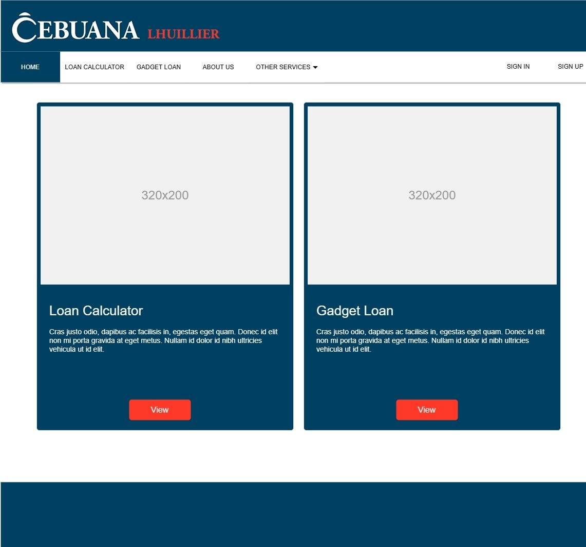

**Sign In Page**

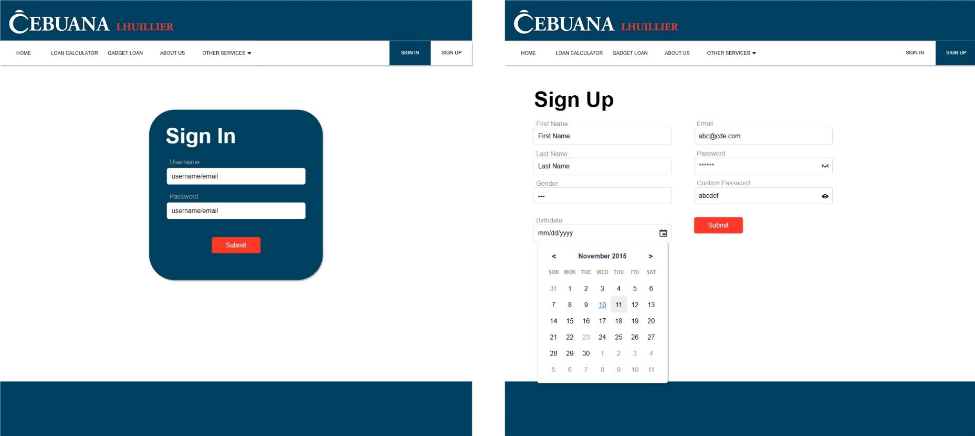

**Sign Up Page**

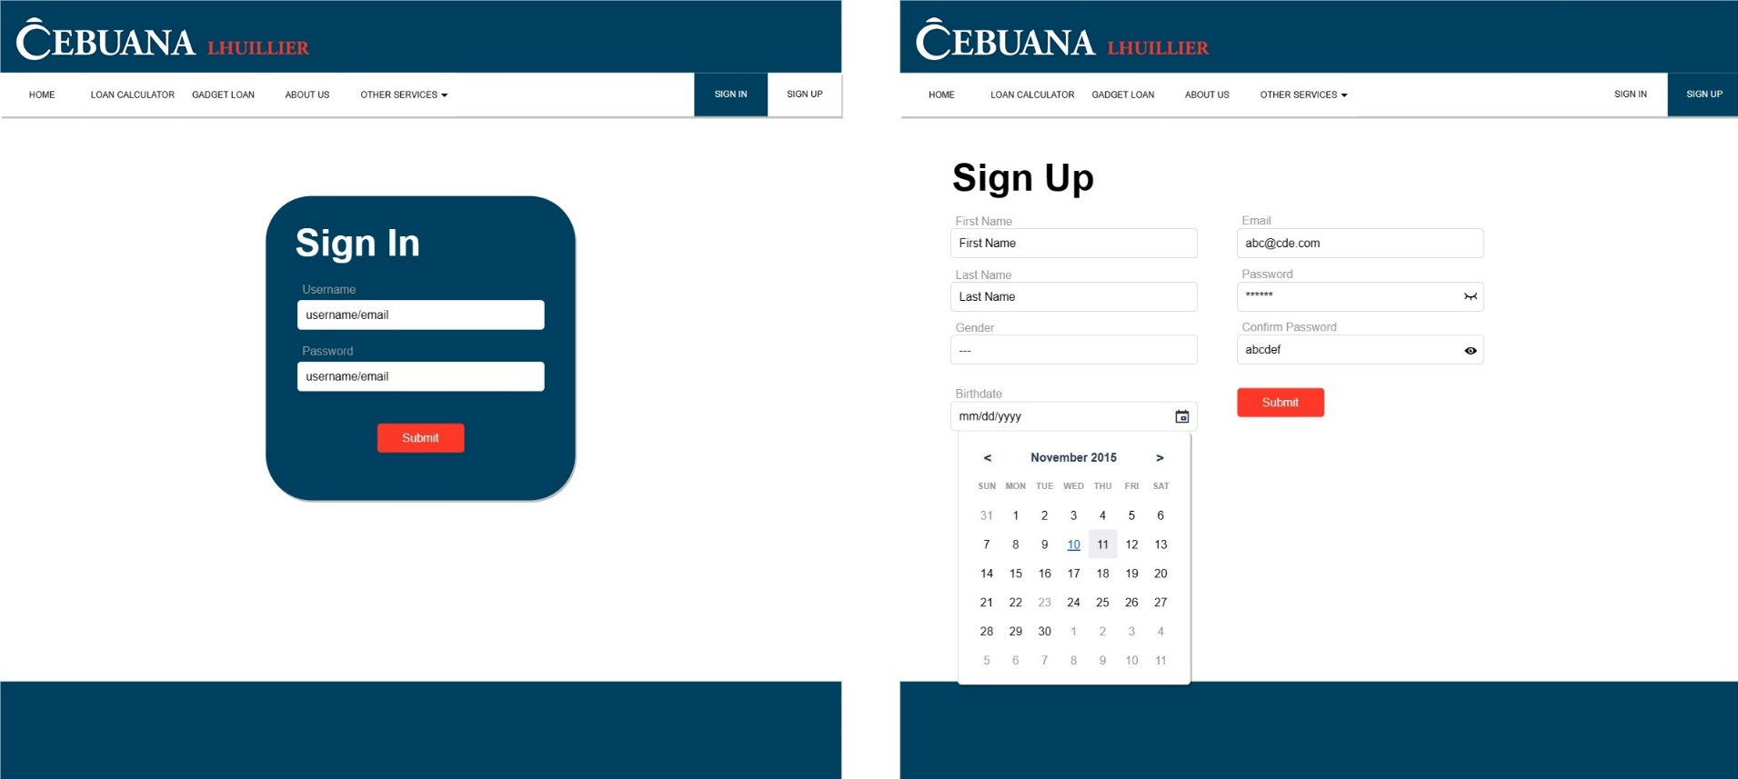

**Gadget Loan**

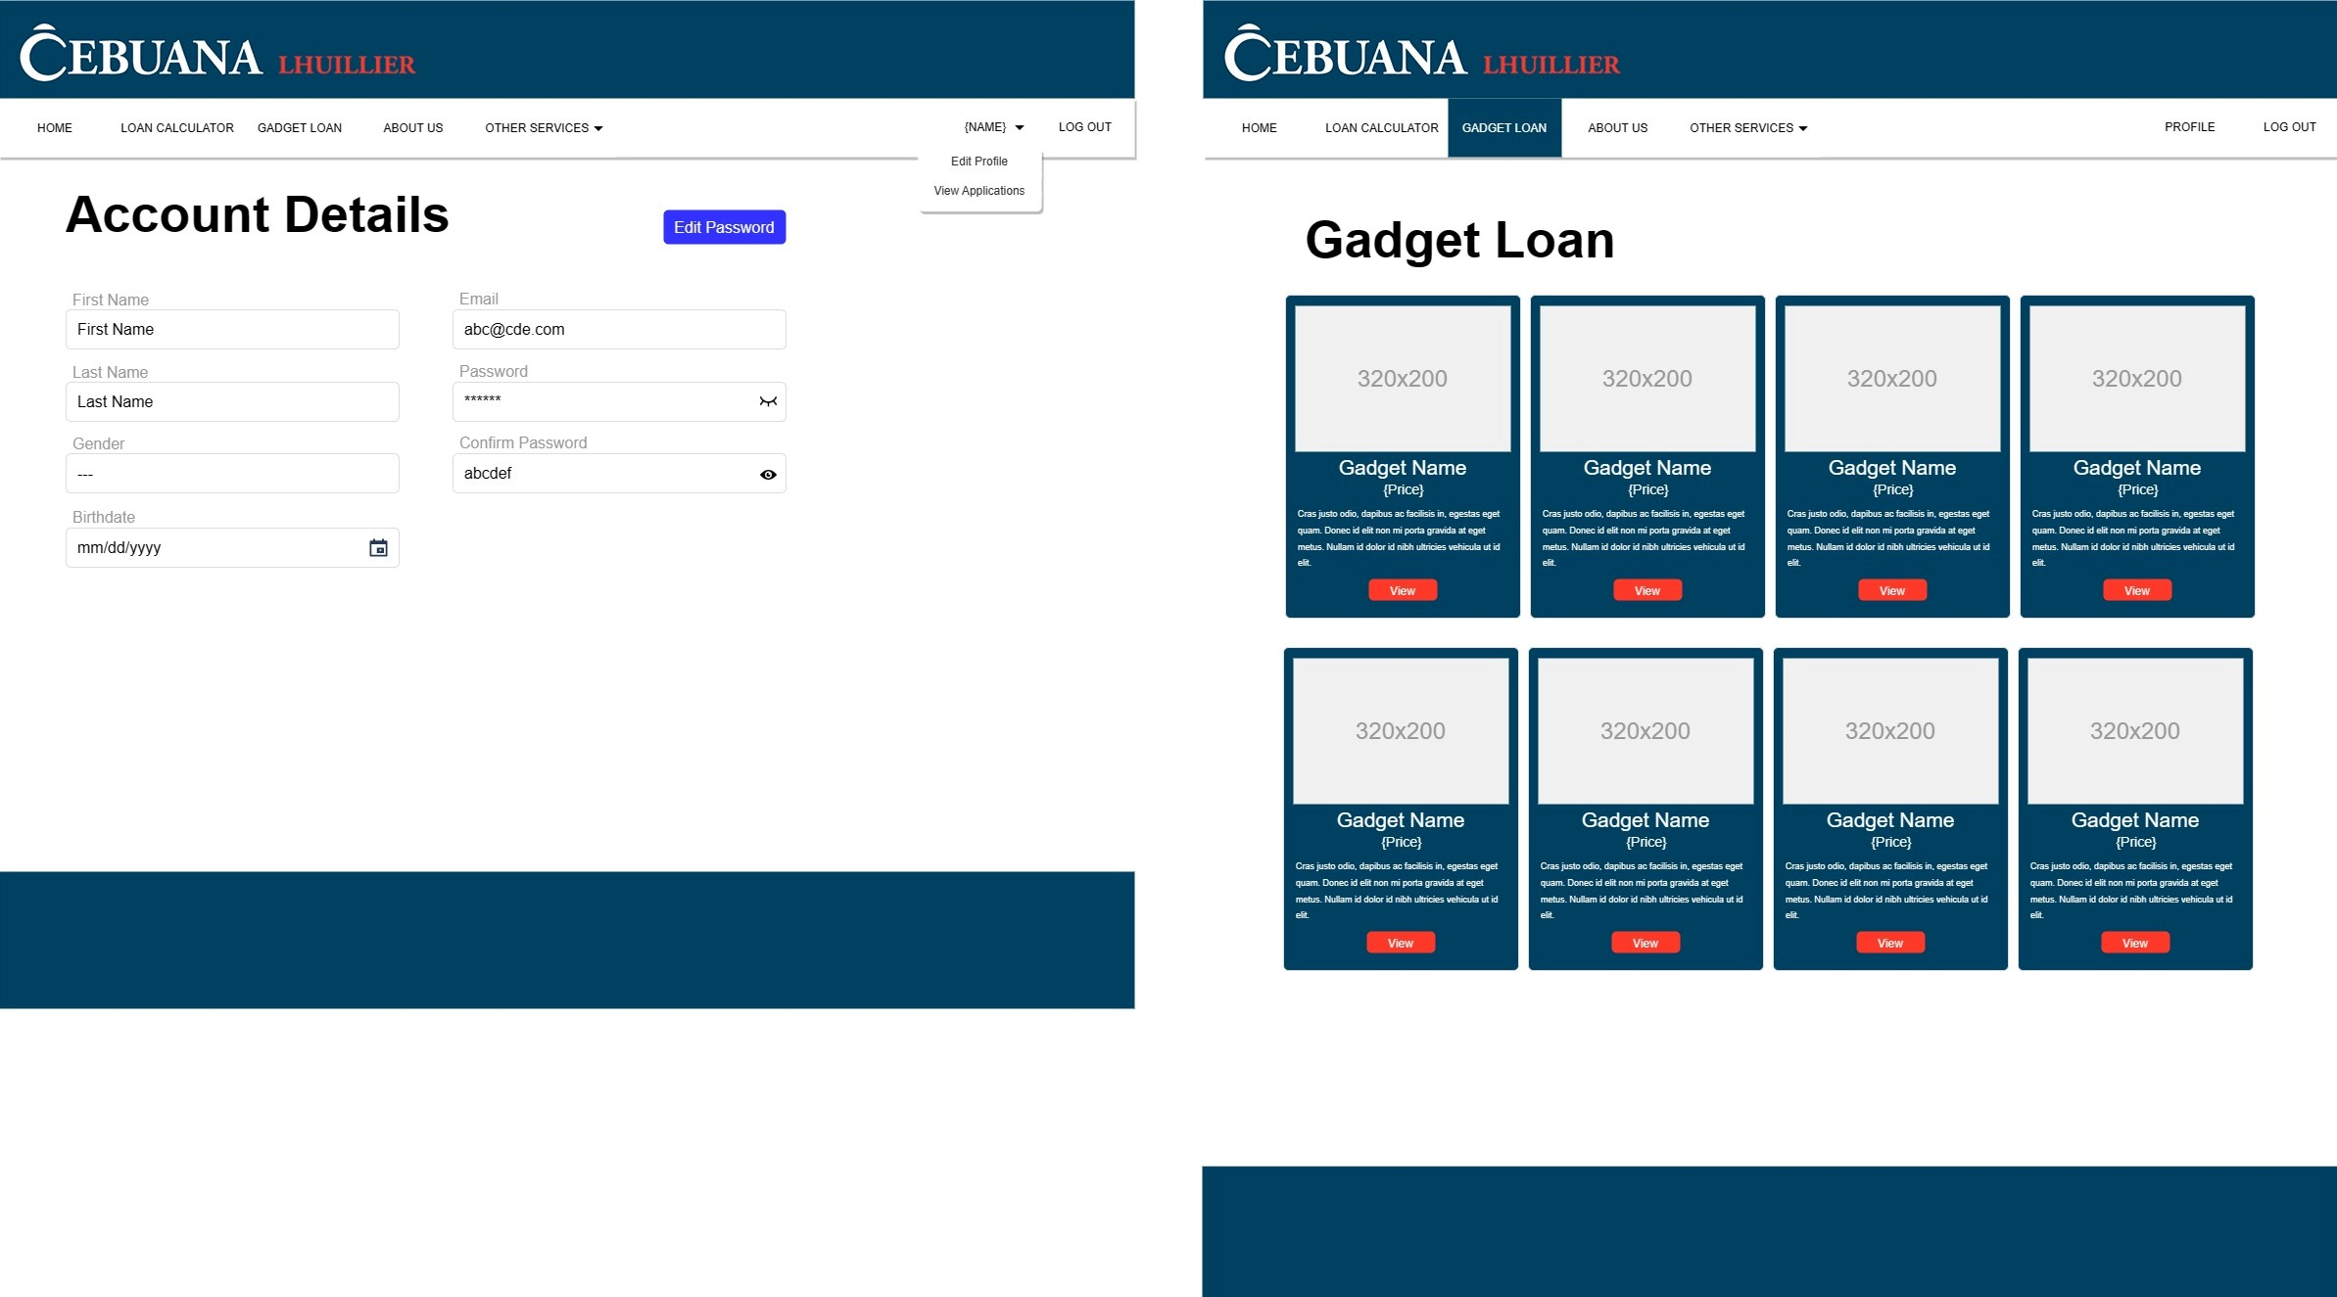

**Account Details**



**Gadget Loan**

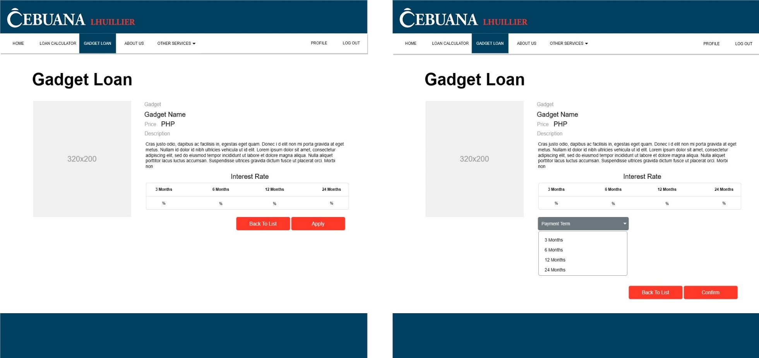

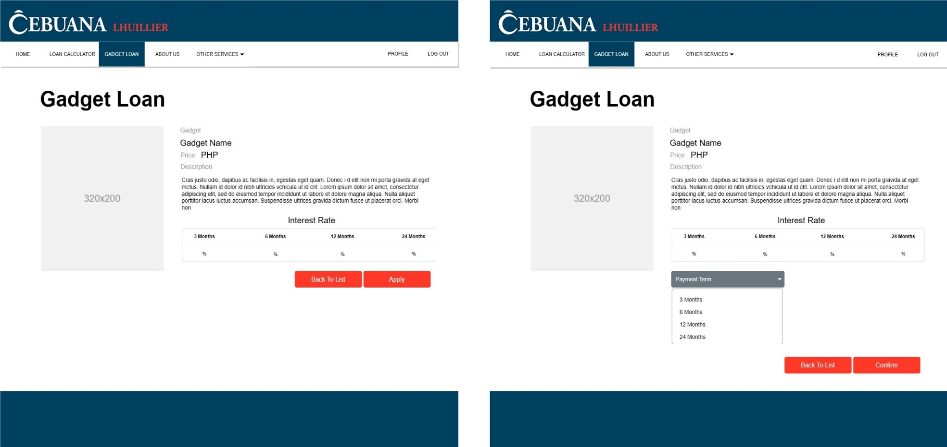

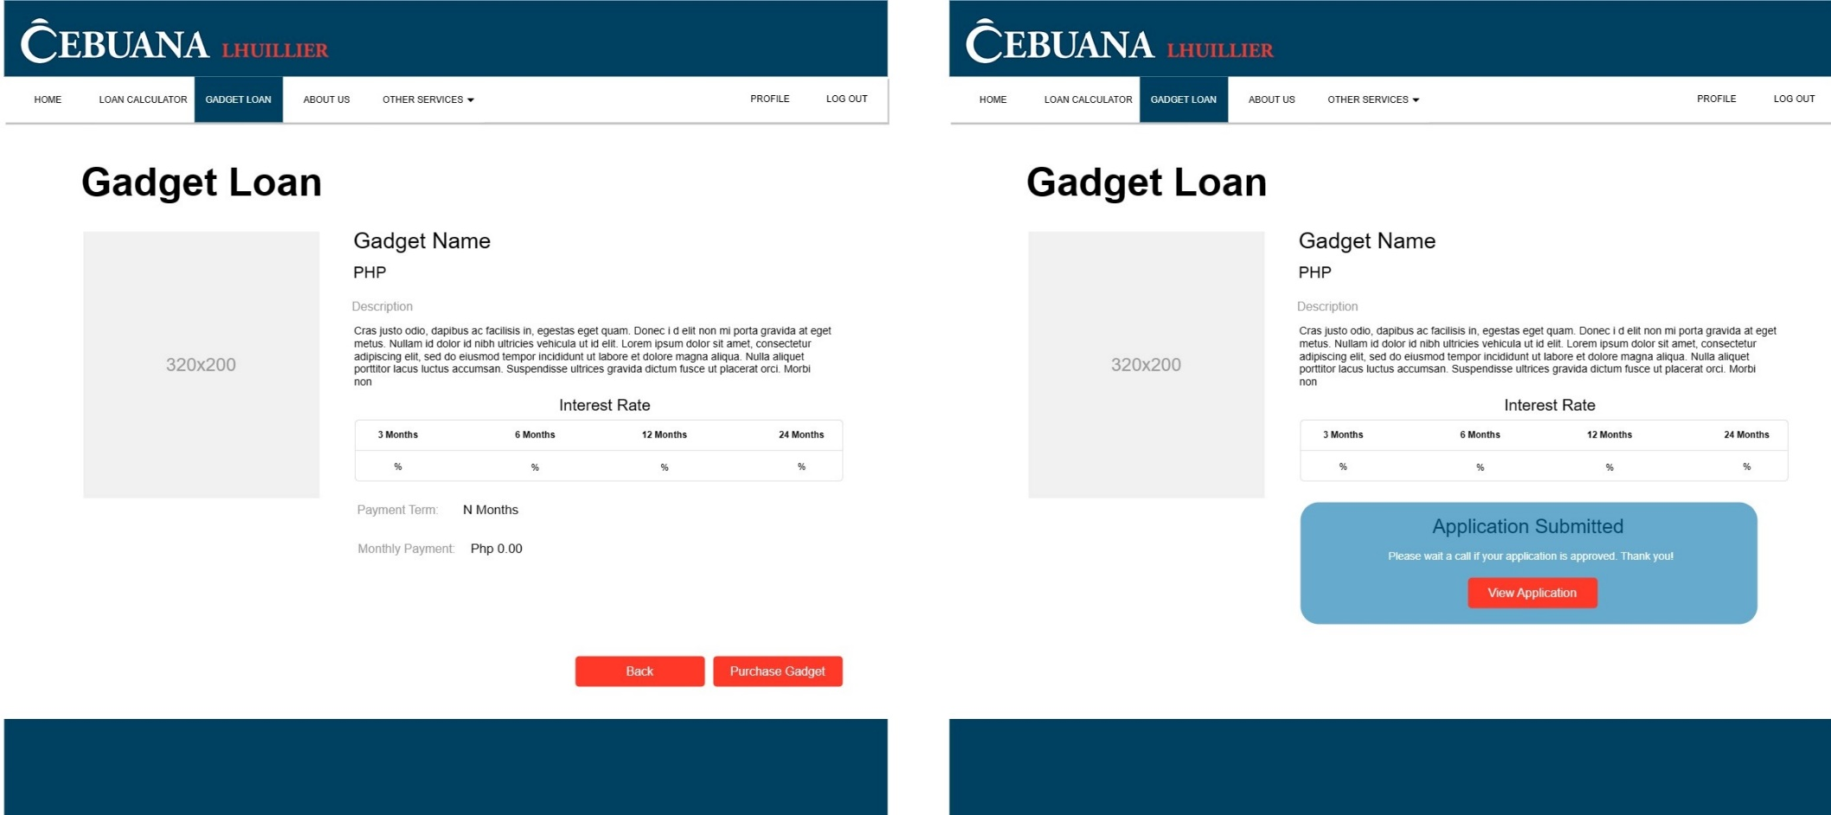

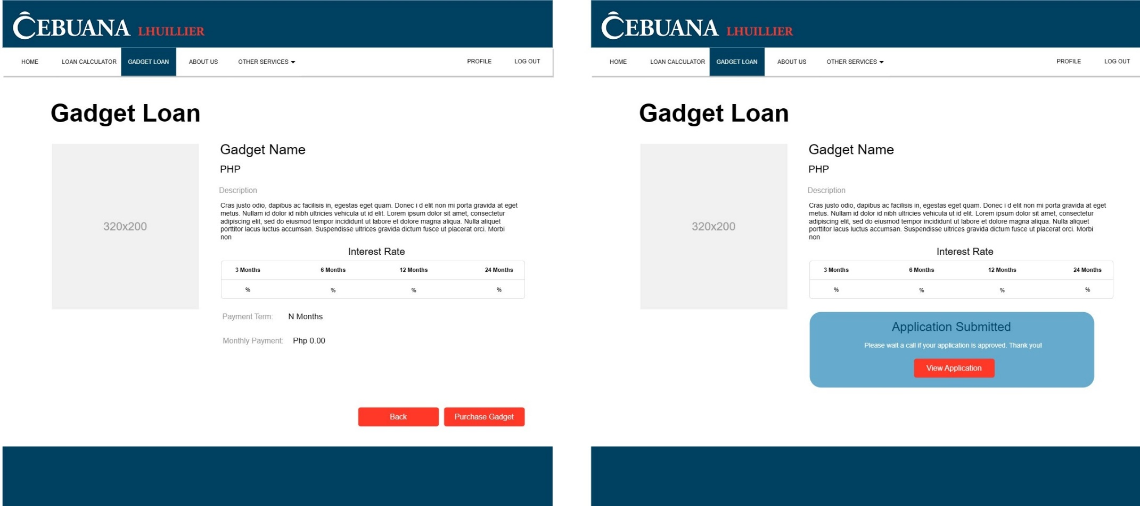

**Loan Calculator**

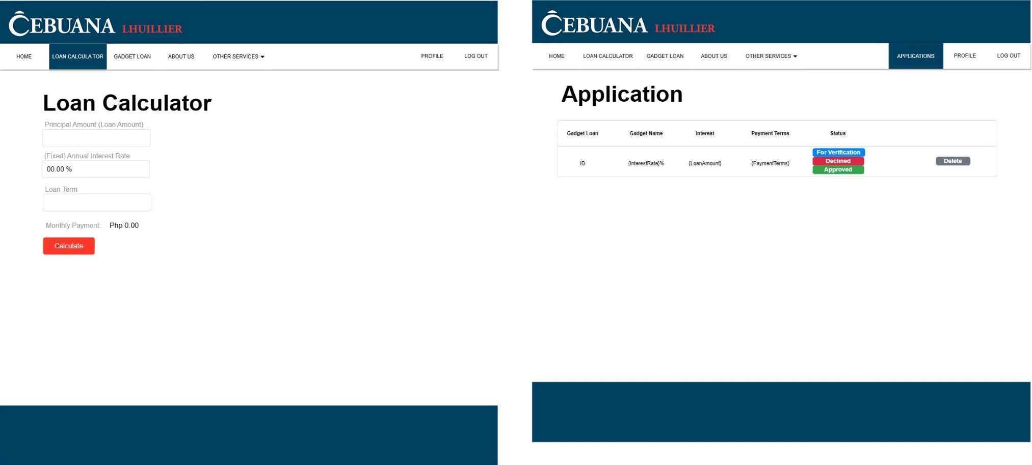

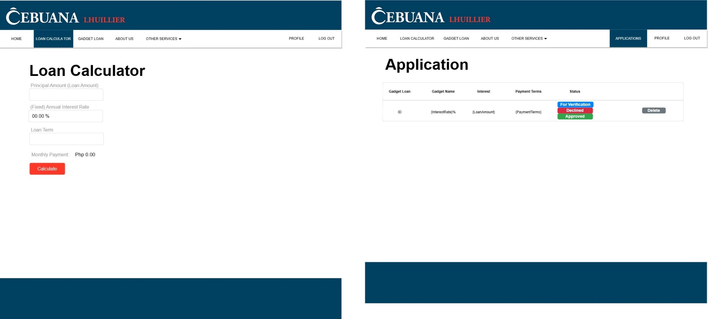

**Administrator Side**

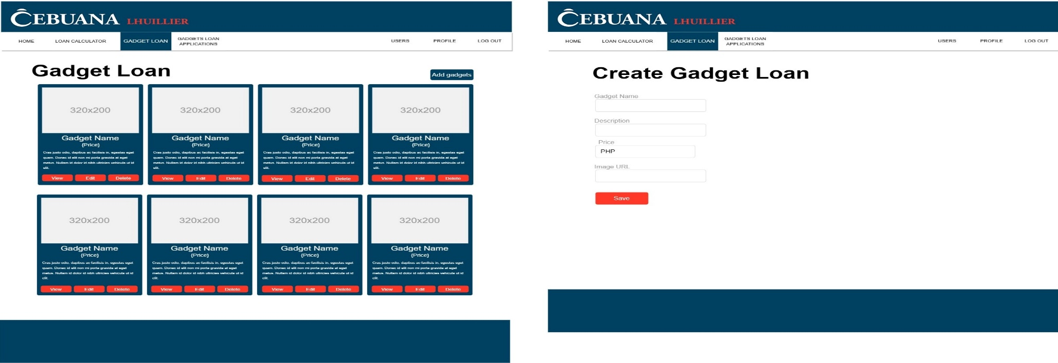

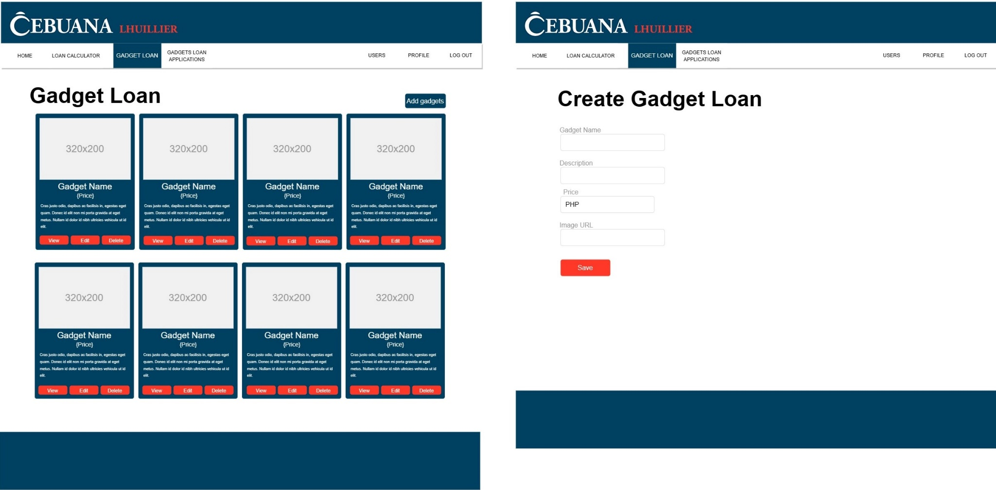

**Manage Purchases**

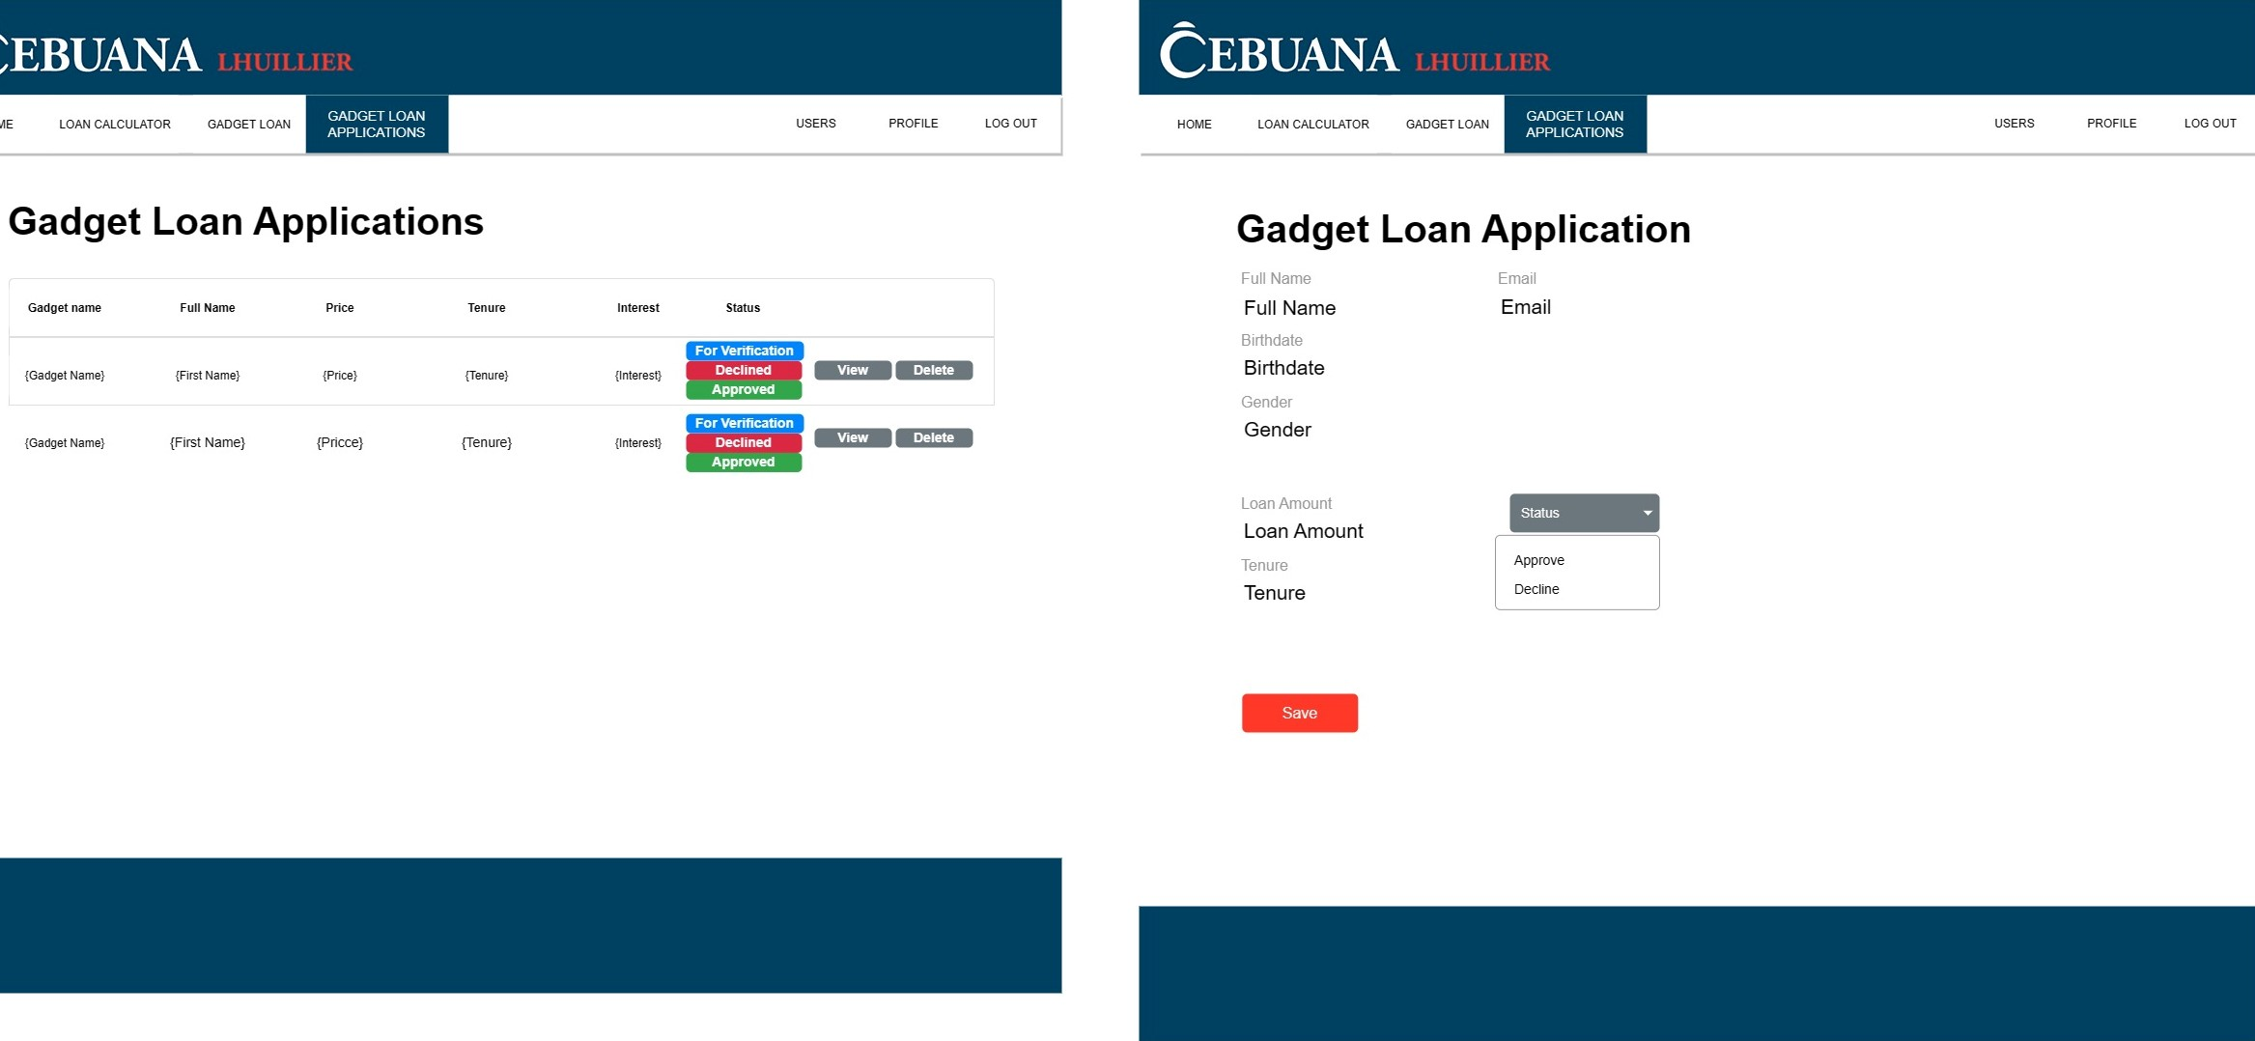



**User Guide**

**Home page**

Users can navigate using the menus provided in the page headings, or they can immediately click the see button of the features they want to explore.

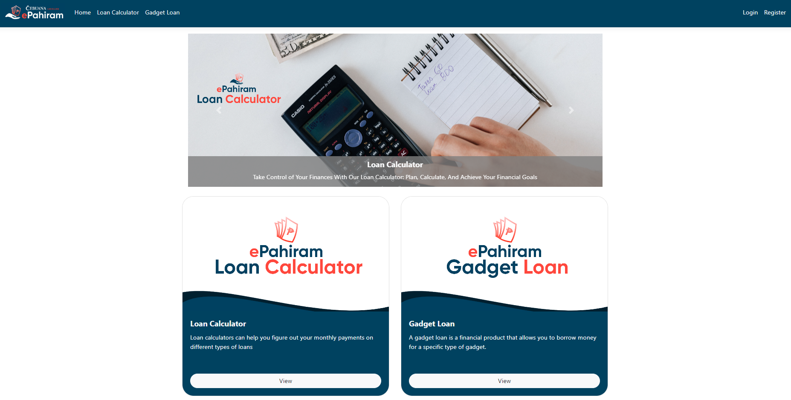

**Loan Calculator**

Loan Calculator is a system function that allows you to calculate your loans based on the parameters listed in the tables below.

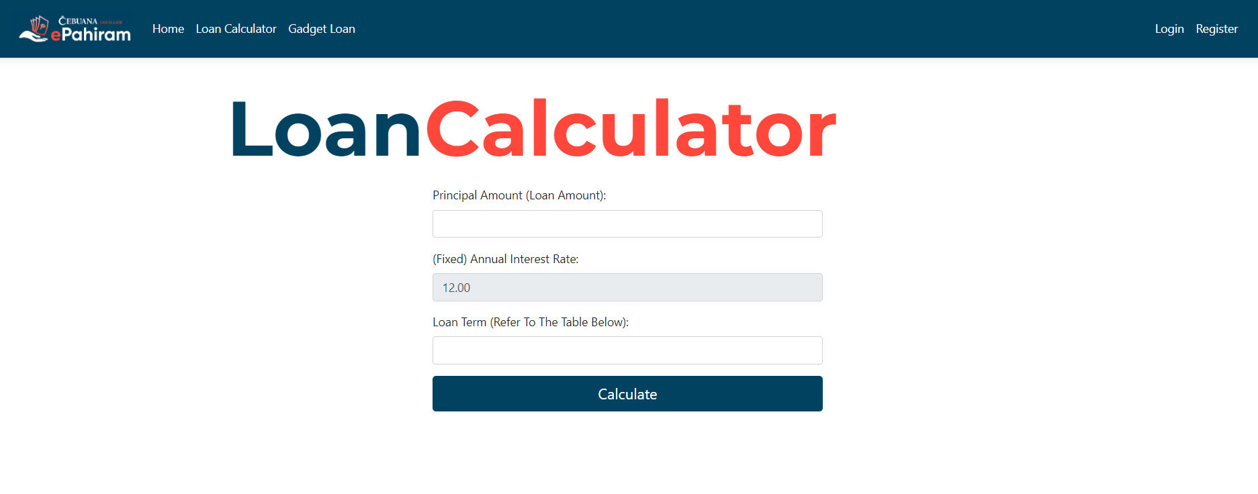

**Listed Criteria**

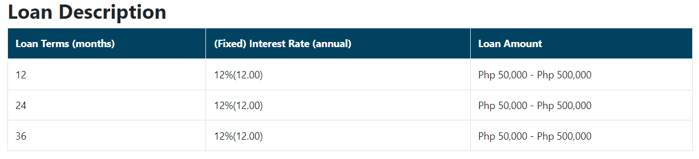

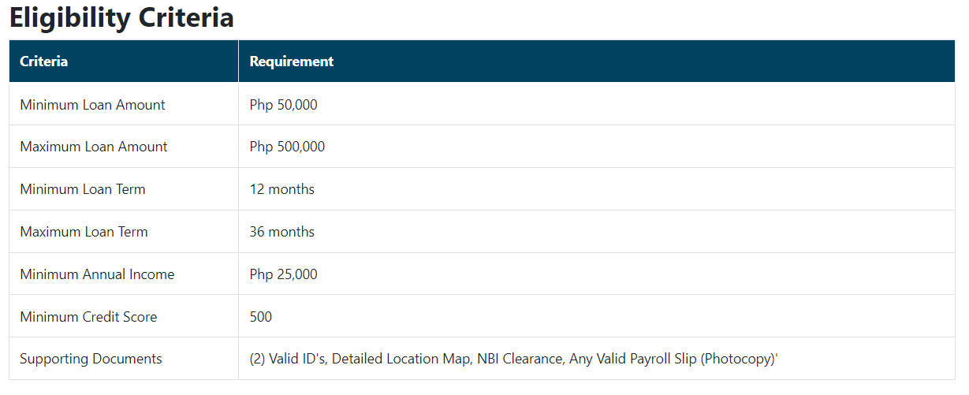

**Gadget Loan**

Users can check the specifics of their chosen gadget by making an account or entering in to an existing account on the gadget loan website, which displays the available gadgets for loan.  
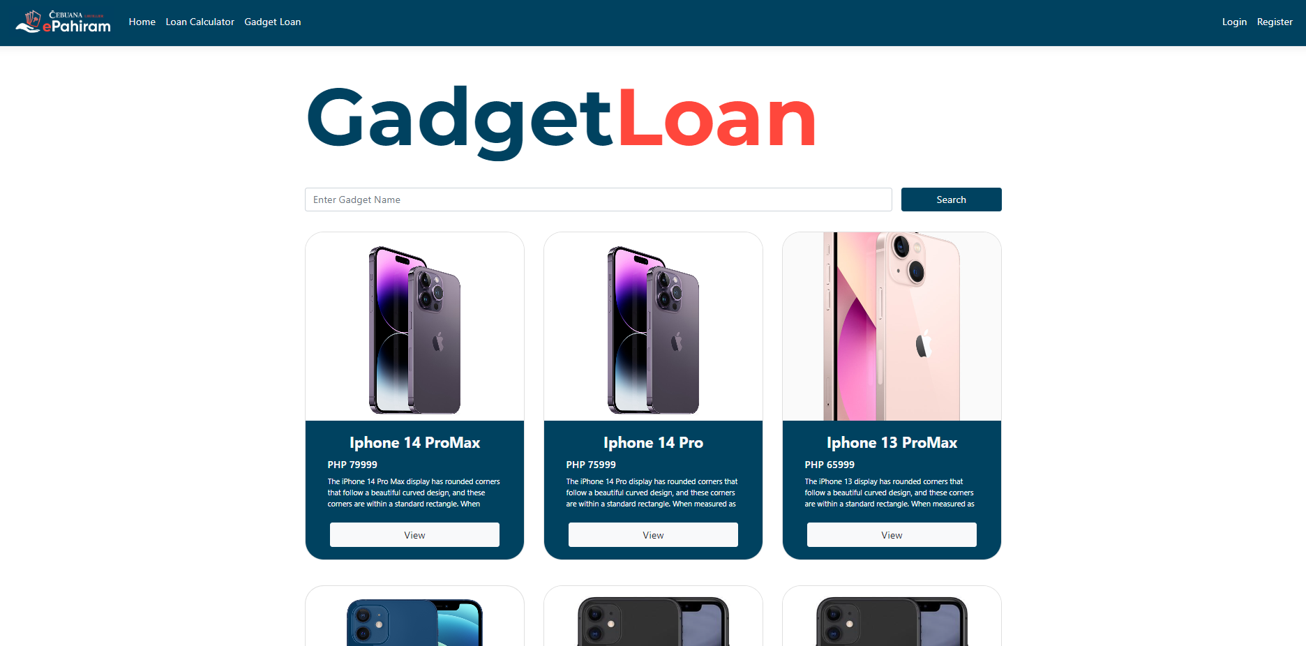

**Sign In Page**

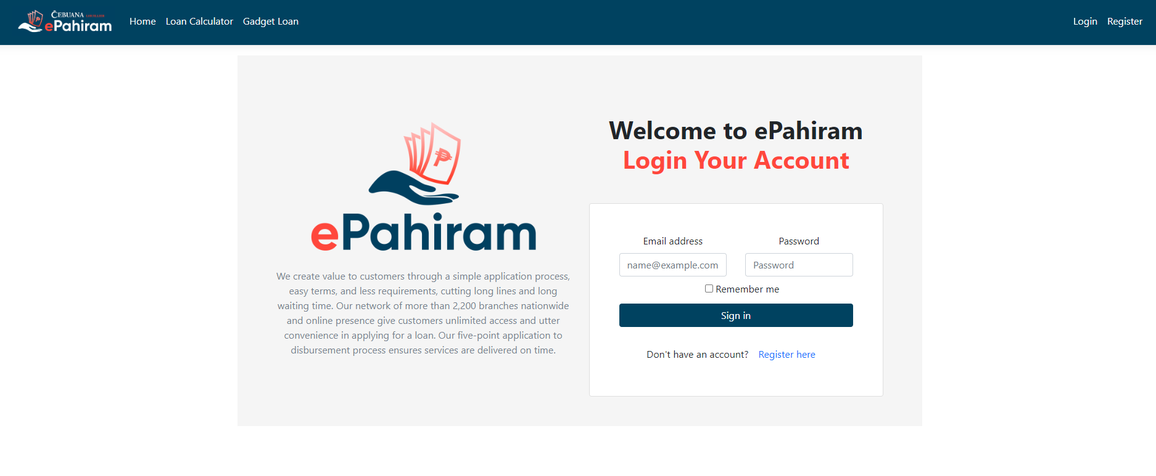

**Sign Up Page**

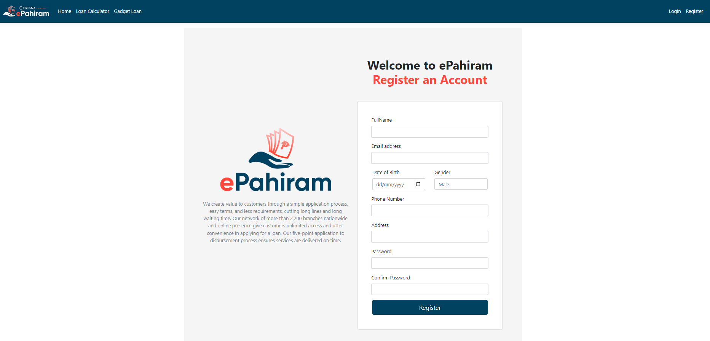

The system will assist in filling out the relevant information required in creating an account; there is a specific validation for each information the user is required to supplement in the provided entity.

**Once Sign In**

Users can use the search bar to hunt for their desired gadget and view its information. If they want to look at all of the gadgets, they can scroll down the page.

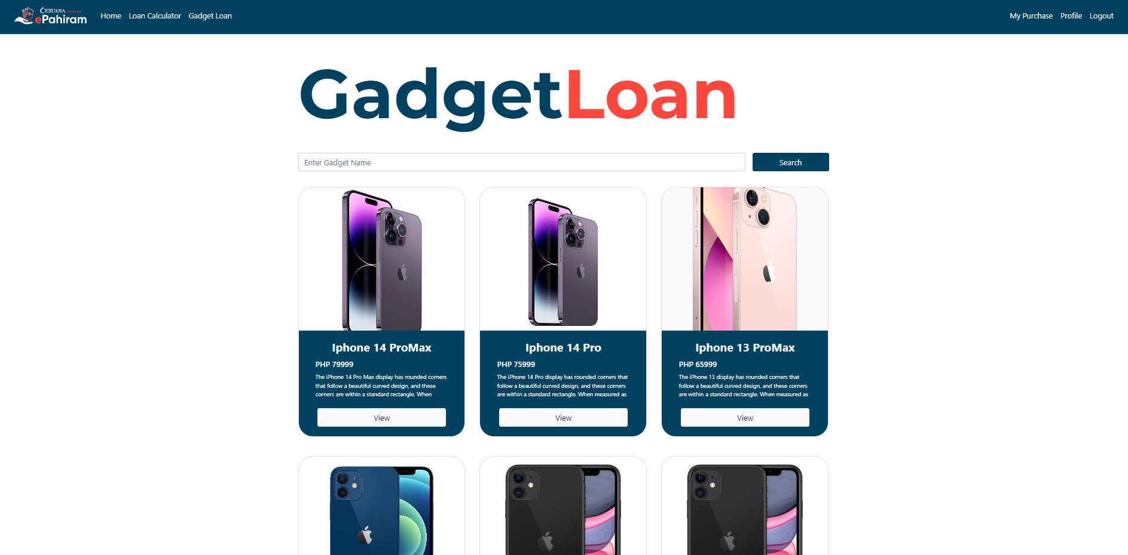

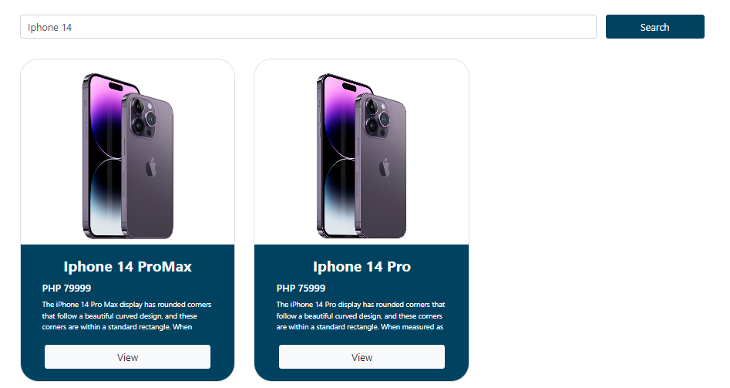

**On-View**

Users can view the overall information about the selected gadget as well as the payment terms. If the customer wishes to apply for a gadget loan, simply click confirm and the page will advance to the next view. (Before confirming, please select the payment term).

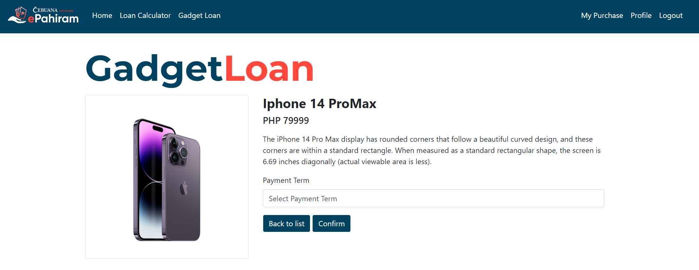

Following confirmation, it will navigate to the confirmation purchase, which displays the computation of the monthly payment based on the payment term selected by the user.

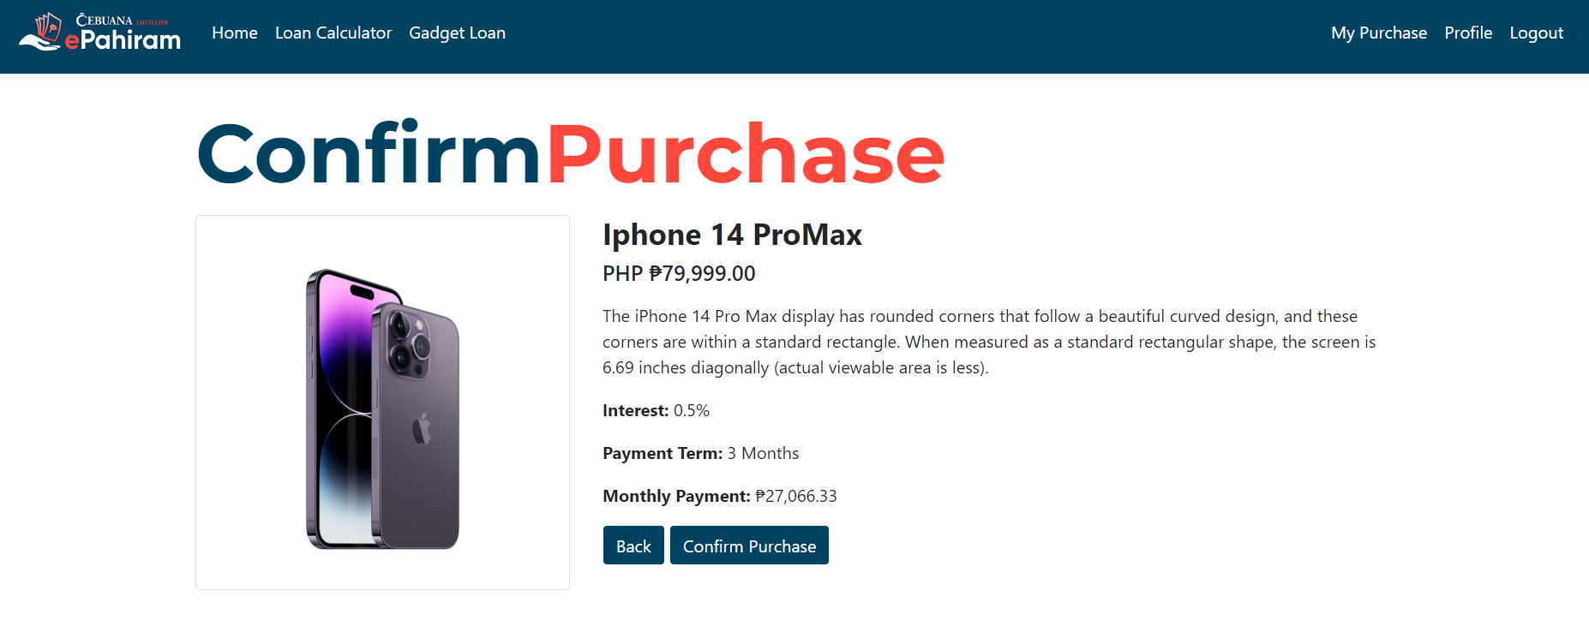

**After Successful Purchase**

The page will redirect to "My Purchase," where the user may examine his gadget loan status and withdraw the purchase.

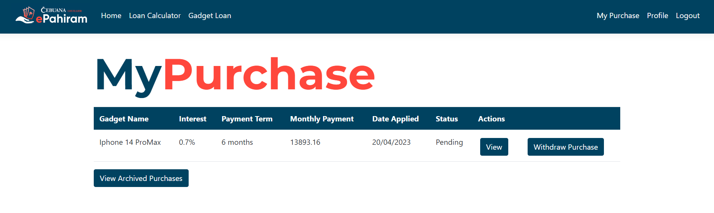

**Please keep in mind that** the system only permits one purchase per user, therefore if the user currently has a loan, the system will not enable the current user to purchase another device loan. Alternatively, the user can purchase another loan if the existing purchase was withdrawn (in this situation, the purchase can only be withdrawn if the status is "Pending", if the admin approves the purchase, the user cannot withdraw the current purchase).

**In another scenario**, if the admin refused the user's loan application, the user is permitted to purchase. All applications that have been withdrawn or refused will be viewable in the archived purchases.

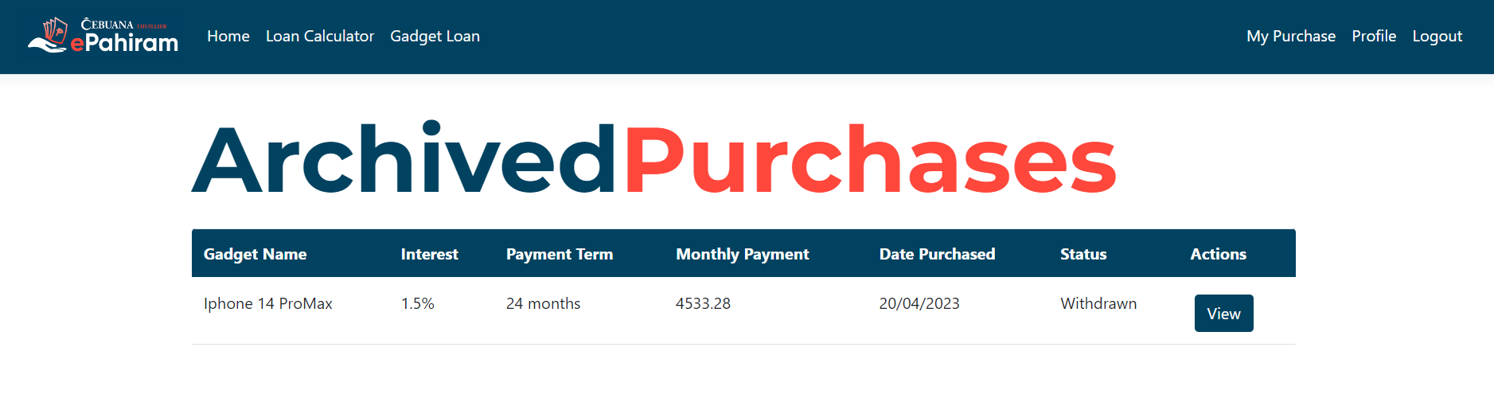

**User Profile**

Users can examine their information and change their password. (Note that the system will lead the user through the process of upgrading the password; the user must follow the criteria.)

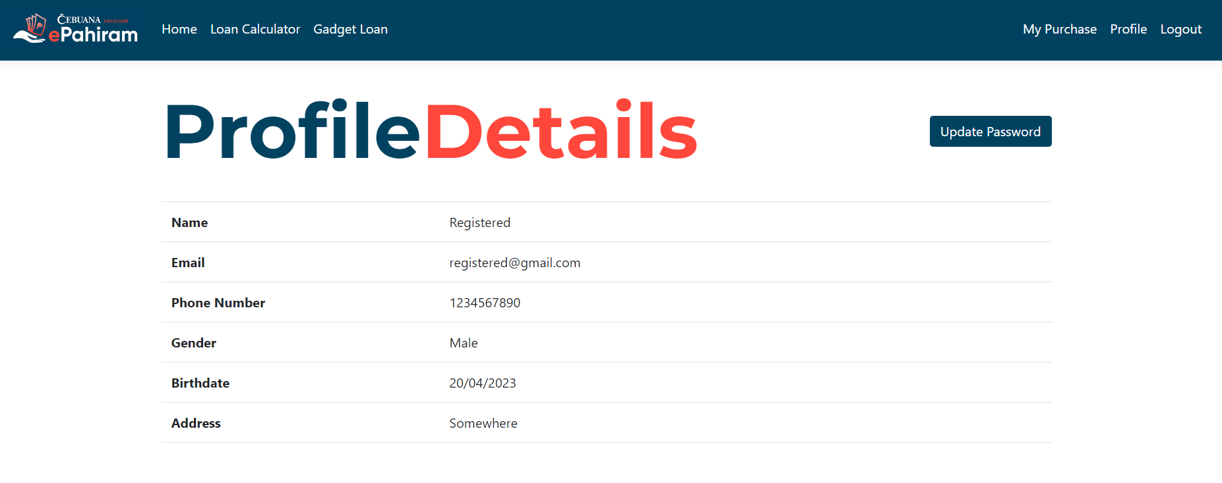

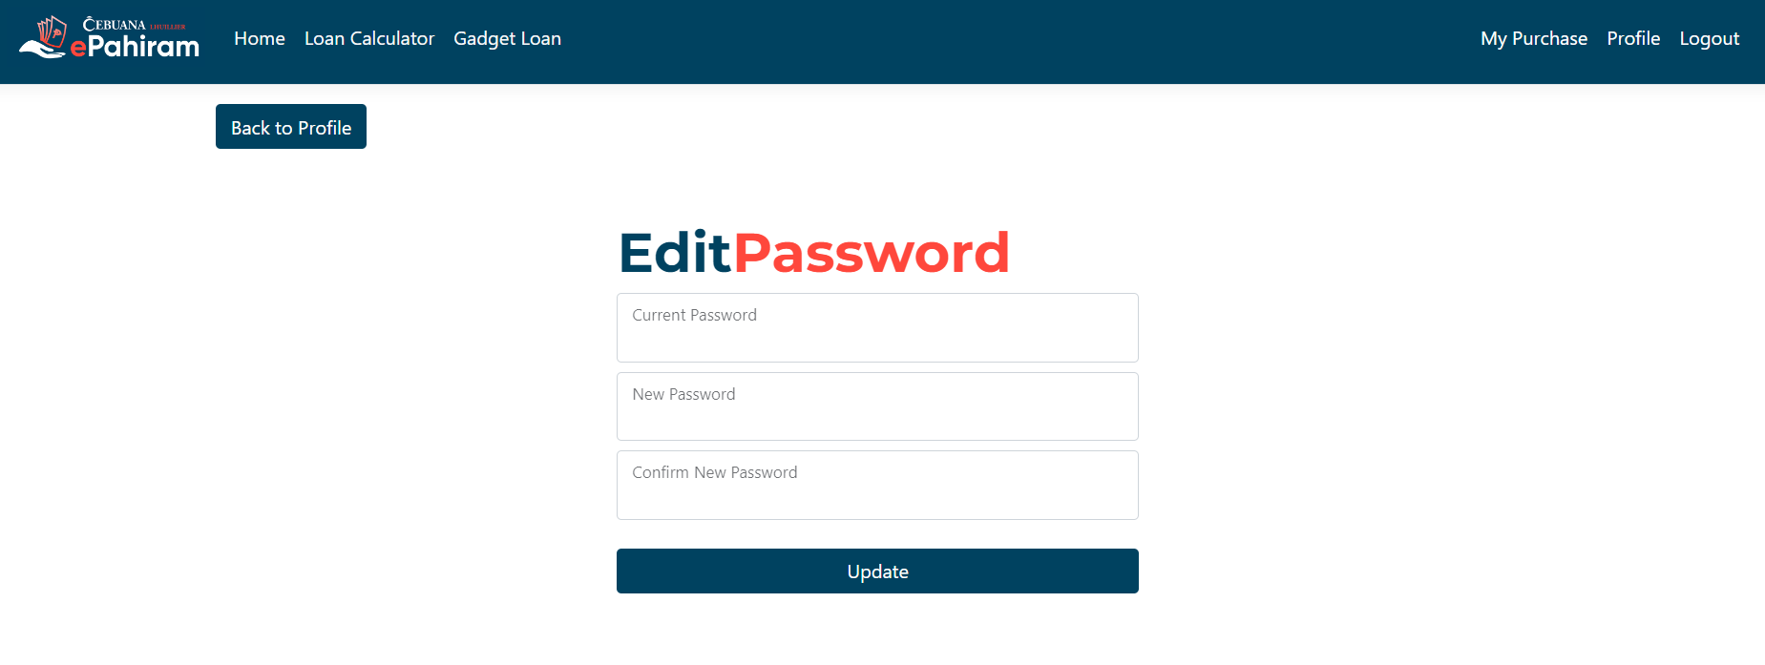

**Admin Guide**

**The administrator** may login to the application using the supplied administrator account.

The administrator can execute CRUD activities for the device loan after logging in; the system has already generated data for the gadgets. **Furthermore**, the administrator cannot delete a device if the user has already purchased it.

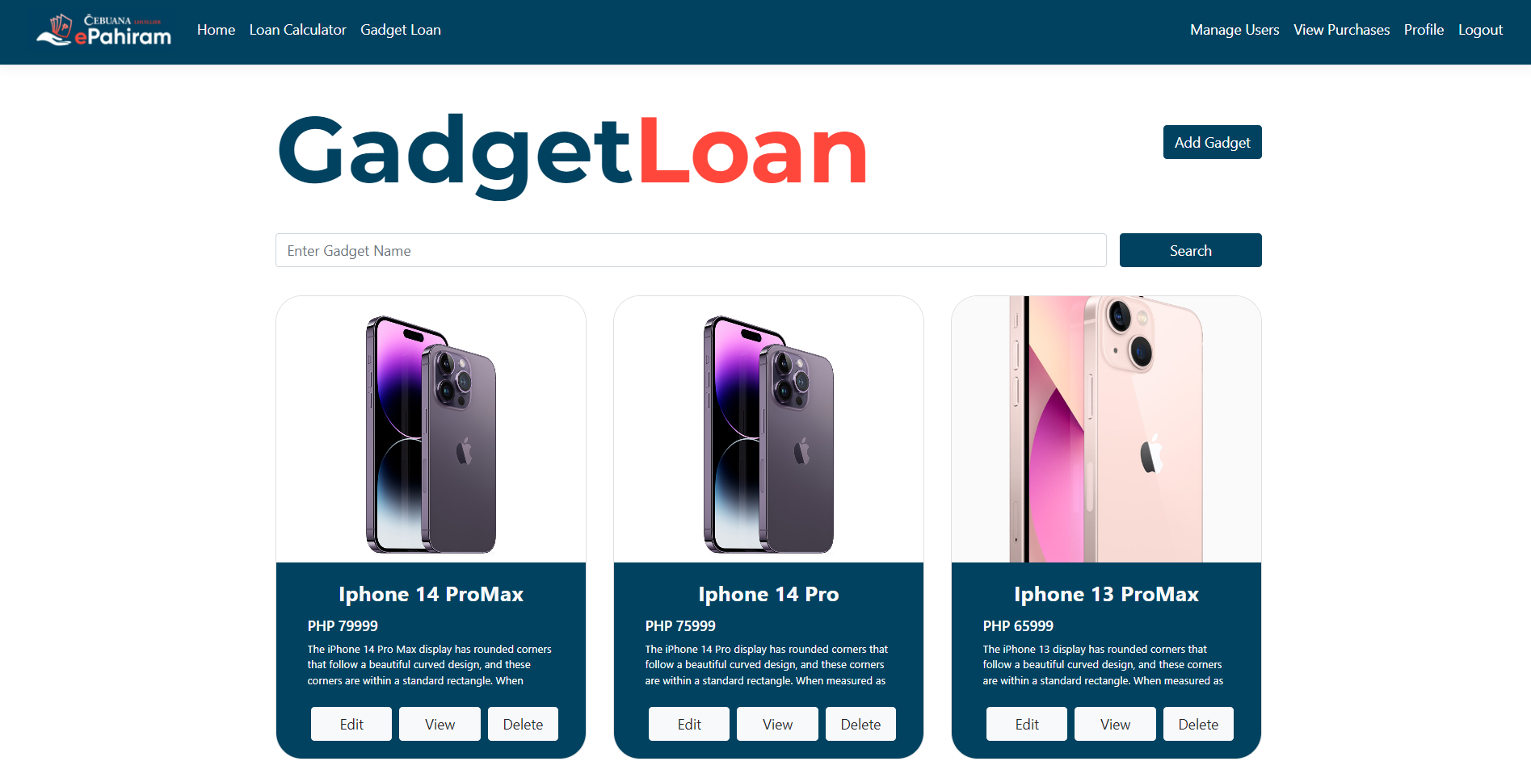

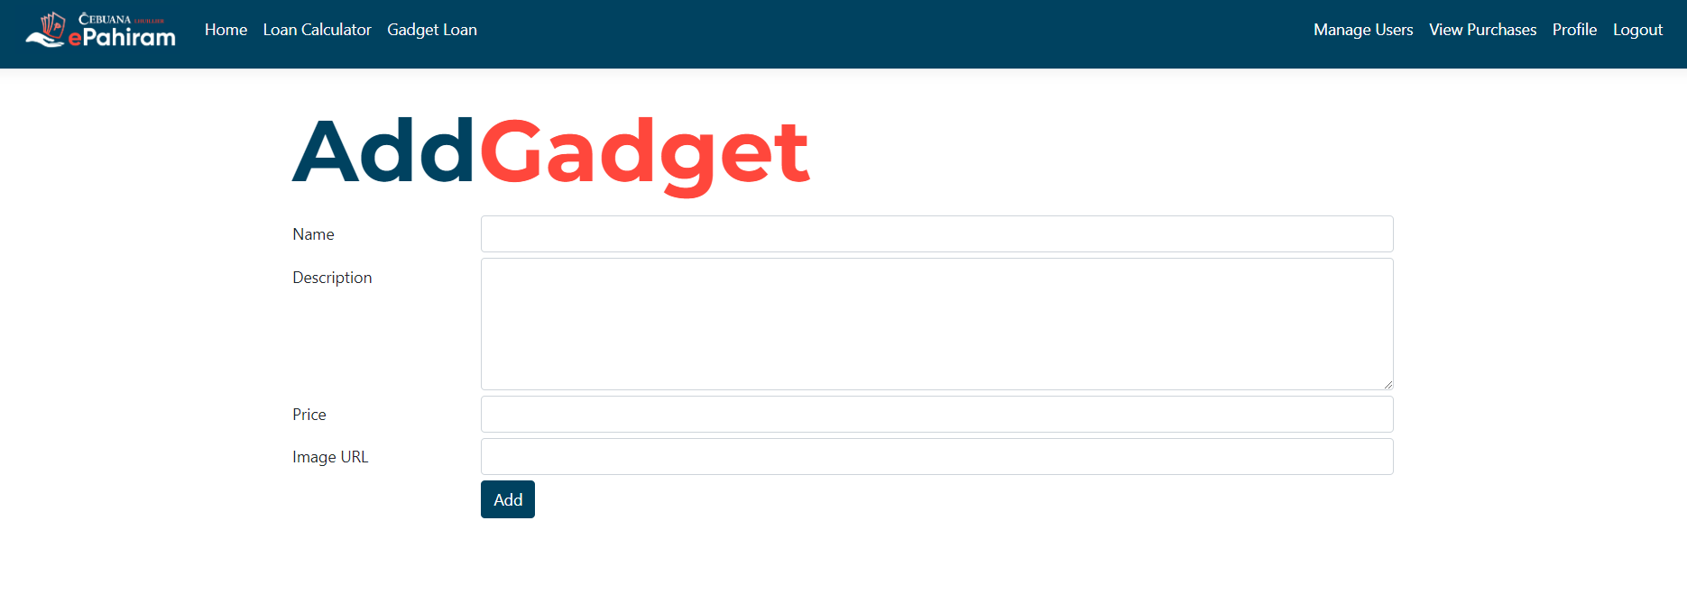

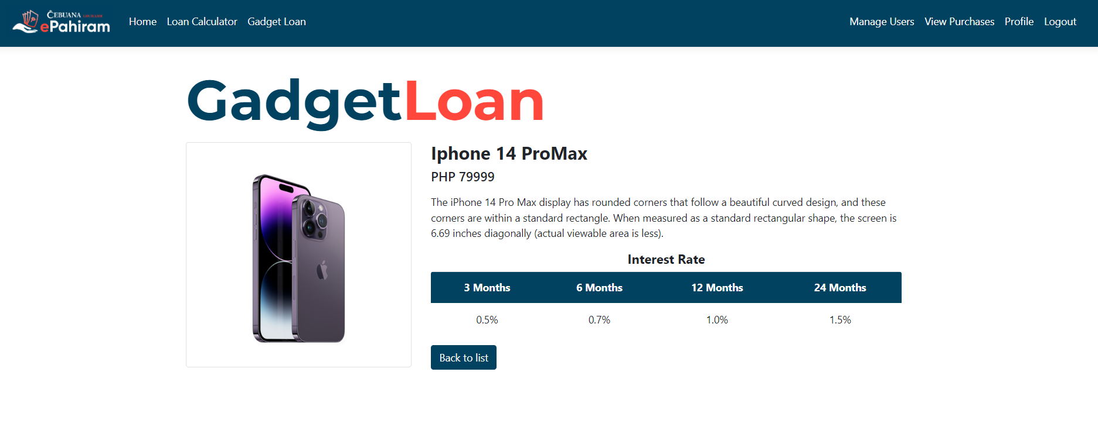

**Manage Users**

The administrator can view the information provided by the user during registration and, if necessary, remove the account.

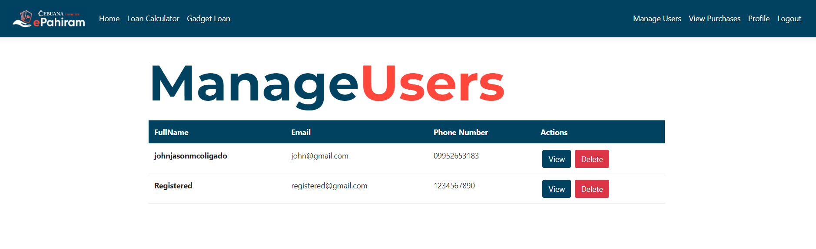

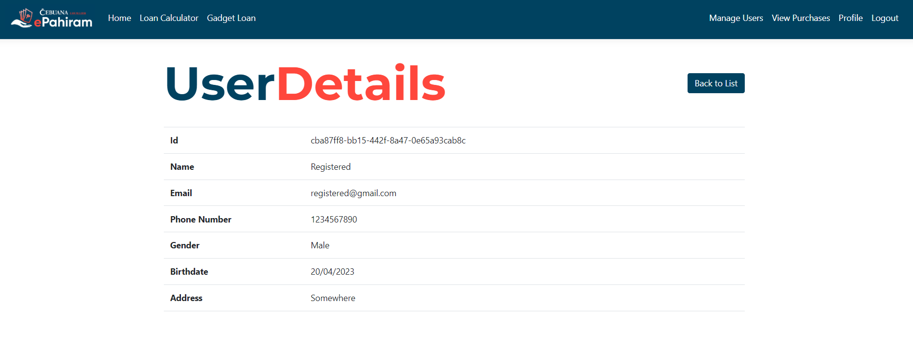

**Manage Purchases**

The administrator can check all of the user's existing purchases and manage the status of each program. Administrators can also see all withdrawn and denied transactions. Finally, **administrators can only delete archived purchases**, which will be reflected in the users' view of the archives.

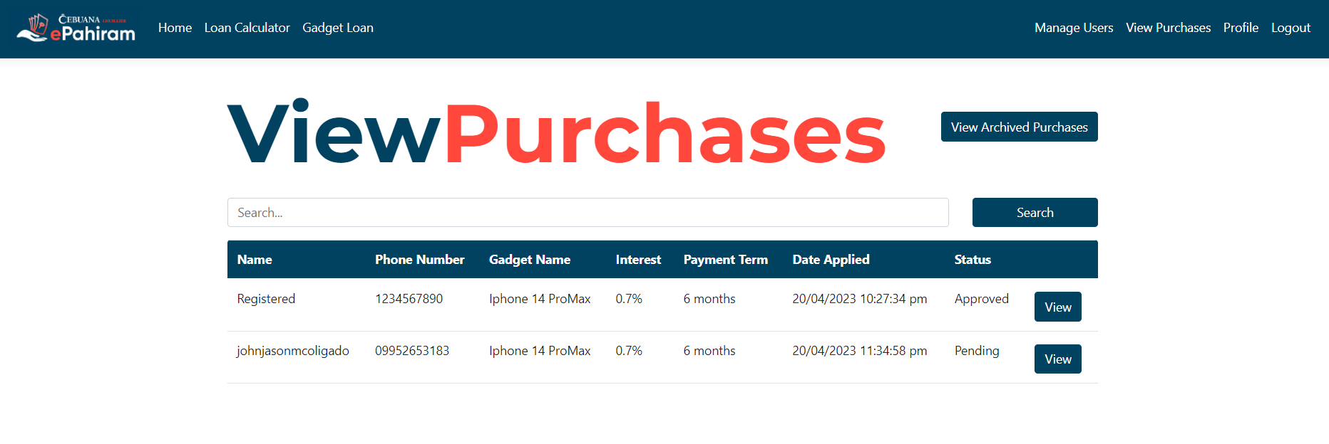

**Upon view**

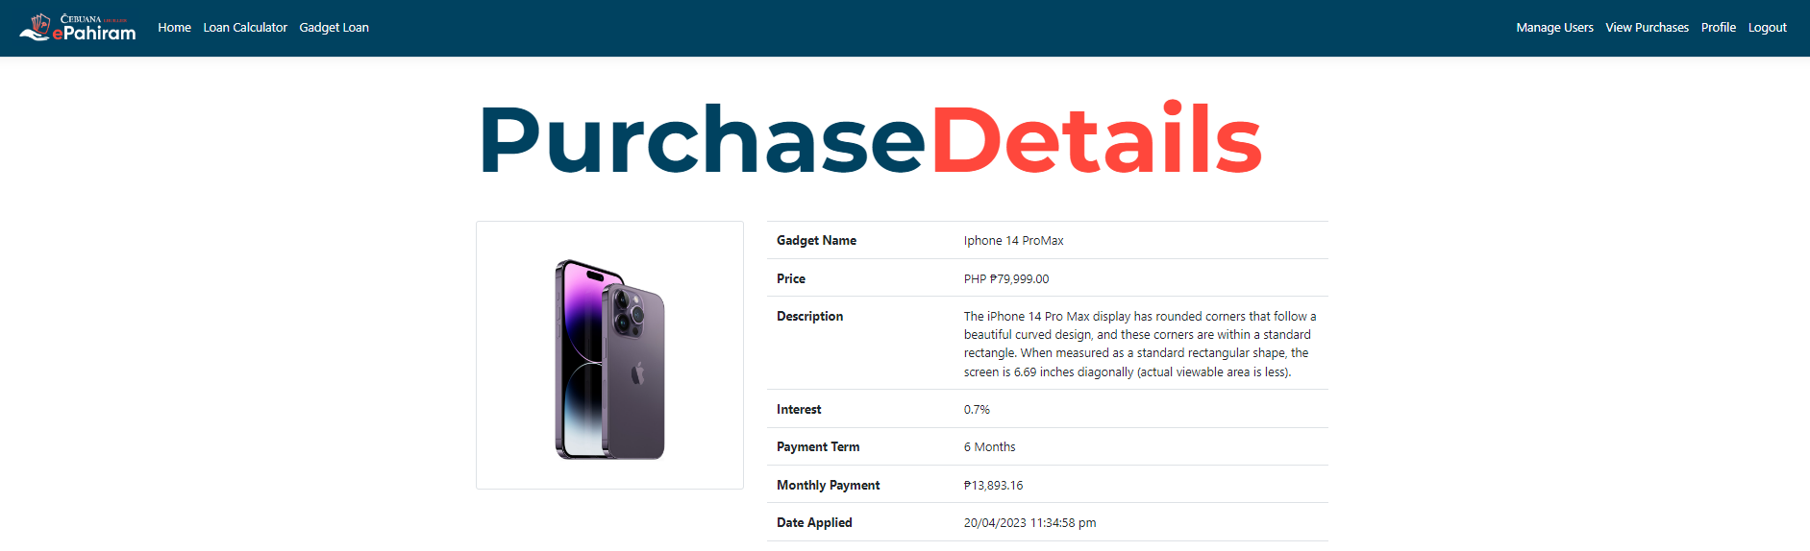

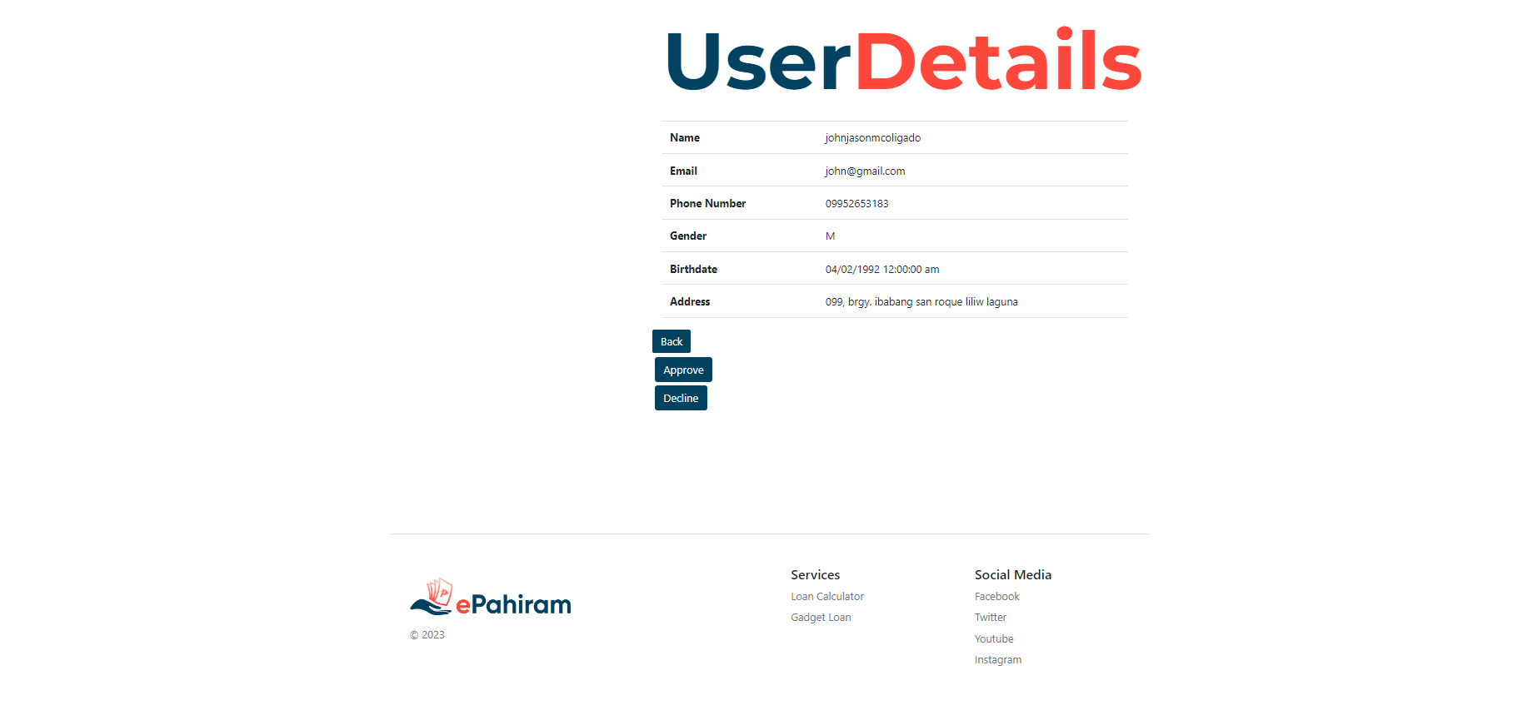

**Archived View**

